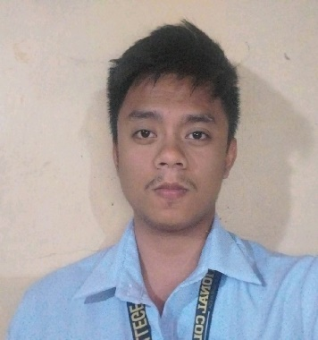

**Eric John L. Palabay**

**ITS, CCST**

E-mail Address:

[ericpalabay777@gmail.com](mailto:ericpalabay777@gmail.com)

LinkedIn Account:

[linkedin.com/in/eric-palabay-315736265](https://www.linkedin.com/in/eric-palabay-315736265)

Credly Account:

www.credly.com/users/eric-john-palabay

Github Portfolio:

<https://swish077777.github.io/github-portfolio/portfolio/>

**Career Objective**

Diligent and committed with a foundational understanding of IT principles, seeking an entry-level position to further expand my knowledge and skills in the dynamic field of Information Technology. Enthusiastic to contribute to a forward-thinking team, Determined to a continuous learning and developing into a proficient IT professional.

**Personal Information**

Birthdate: June 30, 2001

Place of Birth: Floridablanca, Pampanga

Religion: Catholic

Status: Married

**Education Background**

**Guagua National Colleges**

Rep. Eligio Lagman St, Sta. Filomena Rd, Guagua, Pampanga

➢  **Bachelor of Science in Information Technology (BSIT)**

2019 - Present

**Saint Augustin Academy of Pampanga**

Alvendia St. Poblacion, Floridablanca, Pampanga

➢  **Science Technology Engineering and Mathematics (STEM)**

2017- 2019

**Professional Licenses/Certifications**



**Information Technology Specialist (ITS)**

Date Issued: May 2023

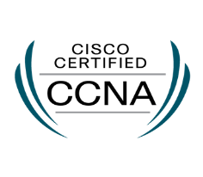

**Cisco Certified Support Technician Cybersecurity (CCST)**

Date Issued: August 2023

**Non-Accredited Certifications**





**Google Project Management**  **Google IT Support**

June 1, 2023 June 1, 2023



**Google Digital Marketing &**

**E-commerce Google Data Analytics**

June 1, 2023 June 1, 2023



**Google IT Automation with Python Certificate**

June 1, 2023

**Short Courses/ Training**

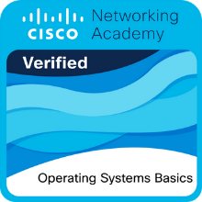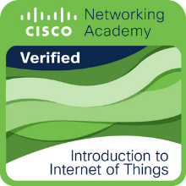

**Introduction to Internet Operating System Basics**

**Of Things** March 10, 2023

April 25, 2023

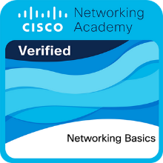

**Networking Basics Computer Hardware Basics**

March 31, 2023 March 27, 2023



**Introduction to Cybersecurity**

March 13, 2023

**Personal Works / Capstone Project Web Development**:

● Rock, Paper, Scissors - <https://swish077777.github.io/Rock-Scissors-Paper/>

● Capstone Project UI – students side - <https://gncinc-clinic.000webhostapp.com/gnci_clinic_webpage/index.php>

➢ Java Script

➢ PHP

➢ HTML

➢ CSS

➢ Bootstrap

➢ Basic Network Configuration

I hereby certify that the above information is true and correct to the best of my knowledge and belief.

Eric John L. Palabay

Applicant